**W.E.STRIPLIN ELEMENTARY**

**KINDERGARTEN GRADE SUPPLY LIST**

**2023-2024**

**4 boxes of Kleenex**

**2 rolls of paper towels**

**3 reams of copy paper**

**3 packs of disinfectant wipes**

**4 packs of crayons (24 count)**

**8 pack Elmer’s glue sticks**

**Optional:**

**1 box of baby wipes**

**2 cans of disinfectant spray**

**Clear or Mesh Backpack**

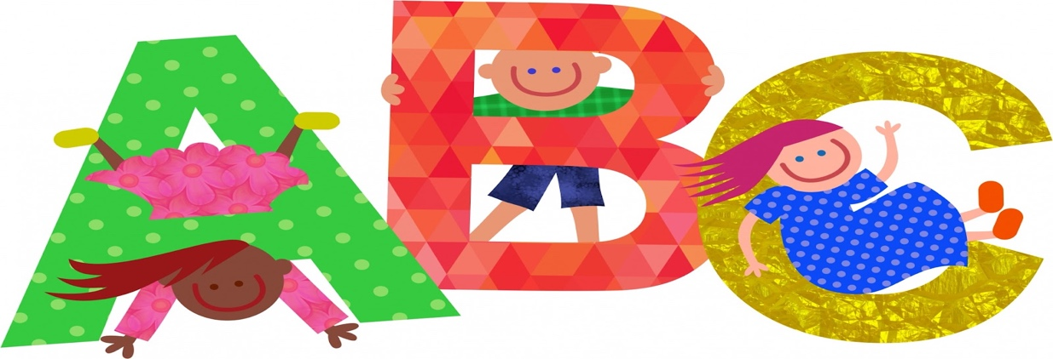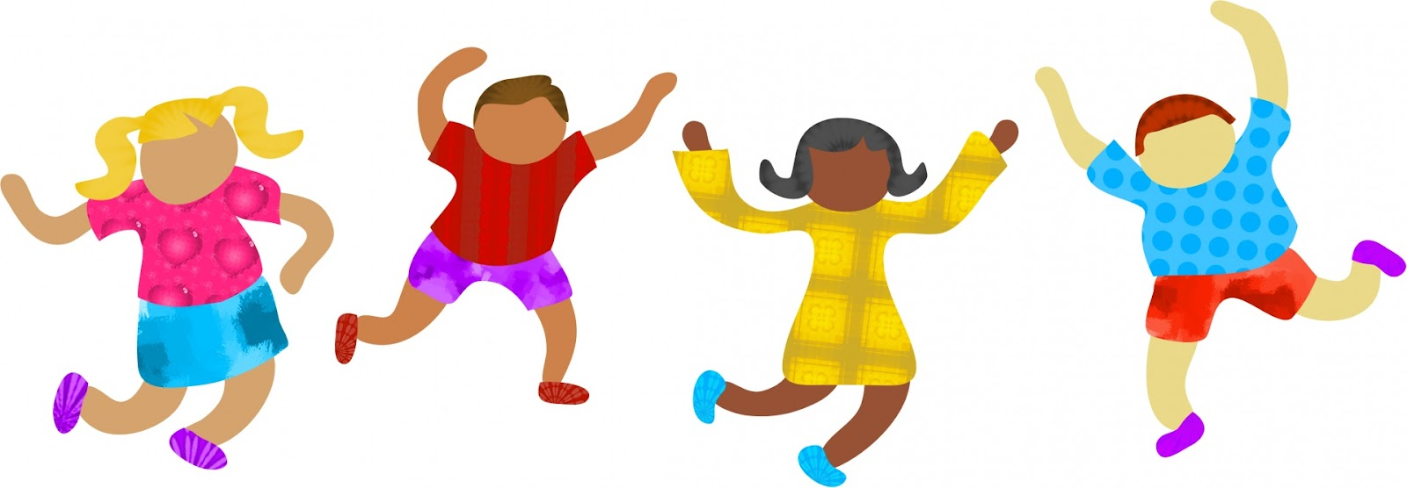

**W.E.STRIPLIN ELEMENTARY**

**FIRST GRADE SUPPLY LIST**

**2023-2024**

|  |  |
| --- | --- |
|  | 4  three prong plastic folders with pockets |
|  | 4-24 count CRAYOLA crayons |
|  | 3 boxes of #2 pencils (yellow pencils) |
|  | 1 box of color pencils |
|  | 8 Elmers Glue sticks (NO LIQUID GLUE) |
|  | 1 pair blunt tip scissors |
|  | 1 zipper crayon/supply pouch (No boxes) |
|  | 4 boxes kleenex |
|  | 2 rolls of paper towels |
|  | 1 bottle of hand washing soap |
|  | 1 bottle of disinfectant wipes (lysol or clorox) |
|  | 1 bottle of hand sanitizer |
|  | BOYS ONLY-gallon size ziploc bags |
|  | GIRLS ONLY-sandwich size ziploc bags |
|  | 1 pack of copy paper |
|  | Headphones (NO EARBUDS and NO WIRELESS)  Clear or mesh backpacks |

**W.E.STRIPLIN ELEMENTARY**

**SECOND GRADE SUPPLY LIST**

**2023-2024**

4 PACKS OF #2 PENCILS

2 REAMS OF COPIER PAPER

2 BOXES OF KLEENEX

2 BOTTLES OF HAND SANITIZER

2 PACKS OF PENCIL TOP ERASERS

1 PAIR SCISSORS

1 CLOROX WIPES

1 PAIR OF EARBUDS OR HEADPHONES

1 HAND SOAP

Clear or mesh Backpack

OPTIONAL:

LYSOL SPRAY

**W.E.STRIPLIN ELEMENTARY**

**THIRD GRADE SUPPLY LIST**

**2023-2024**

2” Binder with clear pocket covers on front and back

2 plastic folders with metal prongs in middle (1 red, 1 blue)

1 pack of dry erase markers

3 packs of pencils

scissors

1 pair of earbuds/ headphones

Hand sanitizer

Clorox wipes

2 boxes of Kleenex

Hand soap

1 roll of paper towels

3 composition notebooks

1 pack of page protectors

Clear or mesh backpacks

**Additional Items:**

Girls - Quart size Ziploc bags

Boys - Gallon size Ziploc bags

$10 Donation

**W.E.STRIPLIN ELEMENTARY**

**FOURTH GRADE SUPPLY LIST**

**2023-2024**

**Backpack** 1 backpack or other school bag that is large enough to hold a 12x10 folder

**Pencils**   Up to 4 boxes of #2 pencils (please no characters or designs)

**Hand Sanitizer** 1 bottle of hand sanitizer

**Tissues** 2 boxes of tissue

**Earbuds/ headphones** 1 pair

**Hand Soap**  1 bottle

**Clorox wipes** 1 container

**Clear or mesh backpacks**

**W.E.STRIPLIN ELEMENTARY**

**FOURTH GRADE SUPPLY LIST**

**2023-2024**

4 - packs of #2 pencils (24 Count)

4 - boxes of Kleenex

4 - bottles of hand sanitizer

4 - packs of paper

Scissors

Earbuds/Headphones

Optional

1- Reams of Copier Paper

Clorox Wipes

Pencil Sharpener with cover

Clear or mesh backpacks

W.E. Striplin Elementary

Fifth Grade Supply List

2023-2024

4 - packs of #2 pencils (24 Count)

4 - boxes of Kleenex

4 - bottles of hand sanitizer

4 - packs of paper

Scissors

Earbuds/Headphones

Optional

1- Reams of Copier Paper

Clorox Wipes

Pencil Sharpener with cover

Clear or mesh backpacks